Jeannie Grisham

Bio
The joy in painting for me lies in the process of creating. As soon as I dip my brush in water, load it with the pigment and introduce it to paper, I’m in a different world. The painting starts with transparent watercolor and continues developing darks while managing to keep the lights. During this process I usually end up adding gouache to the work. It is great fun to manipulate and adjust the textures until the results are pleasing. The painting is considered finished only when it feels just right. Any media, as long as it is water soluble, is fair game, and any tool I can think of to help create textures on hot press paper is a welcome find.

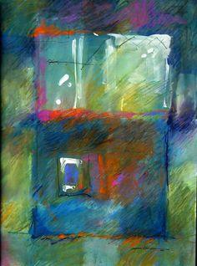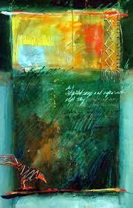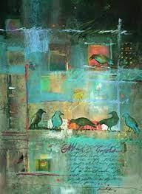

Project Plan
If you are looking to unleash your creative juices this year and try something new, Jeannie Grisham invites you to come and play in her experimental watercolor class. You'll learn how to use watercolor in a unique and unexpected way and play intuitively.

Supply list
1-2 blank pieces of handmade watercolor paper: hot press 140 lbs of any mfg.
Watercolor tubes and colors you normally use.
Assortment of brushes you normally use; example: 1" flat and a round #8.
Add anything to make marks....or scrape.
Example: bamboo pen... stick....letter opener or anything used for scraping.
White crayon, or any box of crayons for a resist.
Additions: salt, saran wrap, water container, blank mat for cropping, masking tape,
anything you can think of is welcome.

Please purchase a white (no color) tube of GOUACHE.
I use this a lot and will show you some tricks.

Please bring a failed watercolor work or two and I will help you discover new life and joy that will be an unexpected "correction" to it.

I will bring water soluble crayons and pencils for you to play with ….

Most important is to be sure and bring curiosity, an open mind and a playful attitude. Expect to have fun. We are going to PLAY!

